Ryan Balachandran
Bio-Information for CS

Homework #2: Pairwise alignment using Dynamic Programming
Due: 2/8/21

The basic core of the dynamic programming routine is as follow:

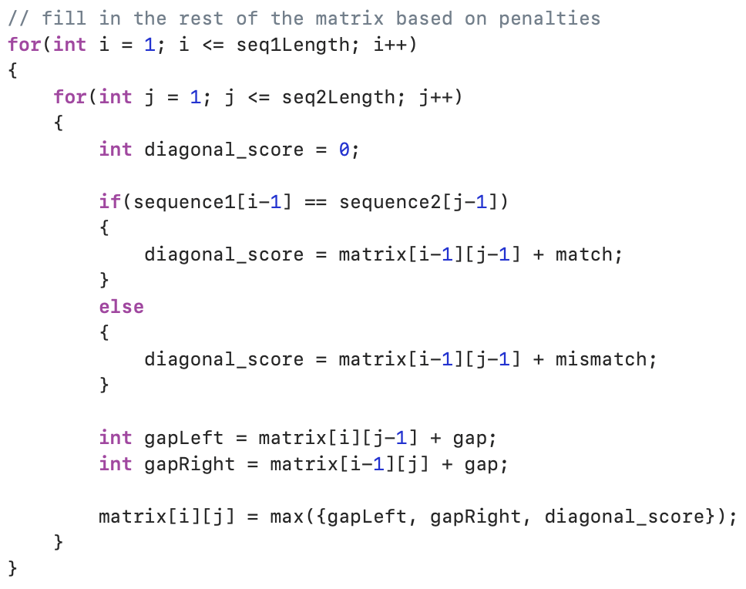
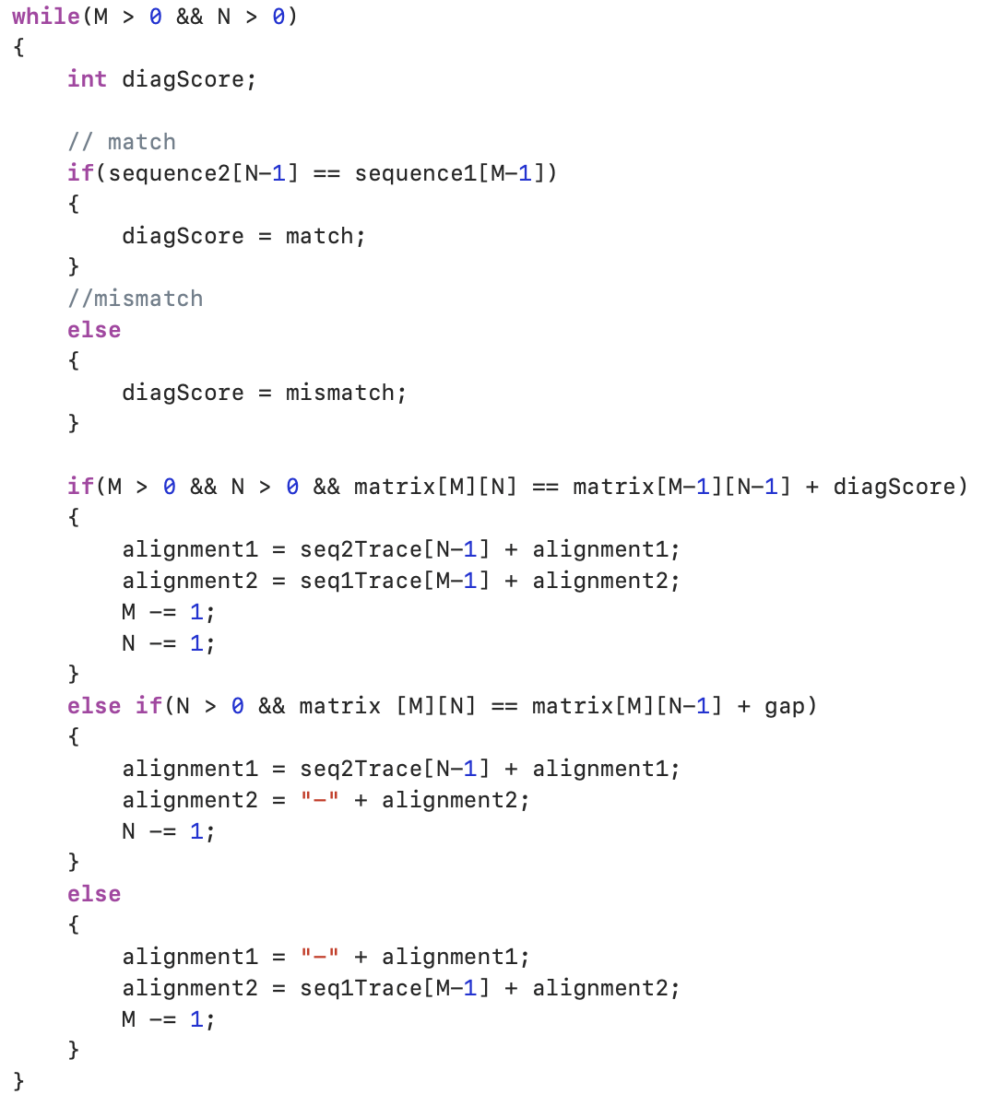

- TEST DATA

- Input
  - String 1: ATGTTAT
  - String 2: ATCGTAG
  - Match score: 20
  - Mismatch score: -5
  - Gap penalty: -10
- Output:
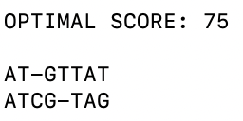

- Input
  - String 1: ATGTTAT
  - String 2: ATCGTAG
  - Match score: 20
  - Mismatch score: -5
  - Gap penalty: -20
- Output
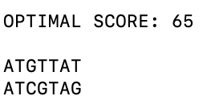

- Input
  - String 1: ATGTTAT
  - String 2: ATCGTAG
  - Match score: 20
  - Mismatch score: -10
  - Gap penalty: -2
- Output
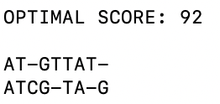

- Input
  - String 1: ATGAATGCGATTTCGGGTGGCC
  - String 2: TTGGCAGGACARGAAGRRCGARACGGAA
  - Match score: 20
  - Mismatch score: -5
  - Gap penalty: -10
- Output
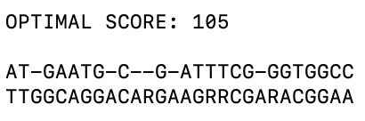

- Input
  - String 1: ATGAATGCGATTTCGGGTGGCC
  - String 2: TTGGCAGGACARGAAGRRCGARACGGAA
  - Match score: 20
  - Mismatch score: -5
  - Gap penalty: -20
- Output
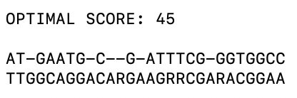

- Input
  - String 1: ATGAATGCGATTTCGGGTGGCC
  - String 2: TTGGCAGGACARGAAGRRCGARACGGAA
  - Match score: 2
  - Mismatch score: -1
  - Gap penalty: -2
- Output
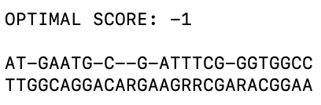

- Input
  - String 1: ATGAATGCGATTTCGGGTGGCC
  - String 2: TTGGCAGGACARGAAGRRCGARACGGAA
  - Match score: 20
  - Mismatch score: -10
  - Gap penalty: -2
- Output
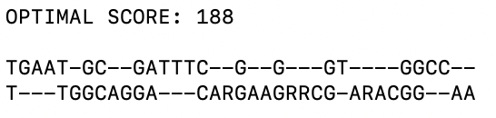

- Input
  - String 1: ATGAATGCGATTTCGGGTGGCC
  - String 2: TTGGCAGGACARGAAGRRCGARACGGAA
  - Match score: 20
  - Mismatch score: -3
  - Gap penalty: -10
- Output
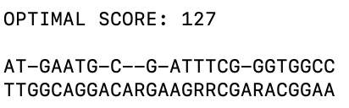

- Conclusion

Different gap penalties can have varying effects on the optimal score and pairwise alignment of the two sequences. The gap penalty effects if the program inputs a gap rather than mismatching two letters in the sequence. If the gap penalty is high, there is less of a chance a gap will be inserted as to if the gap penalty is low.

- Appendix

To run the code, open a terminal and cd into the folder.
Type make
Type ./PAIRWISE
Then type DNA1.txt or DNA2.txt

